Quantum Gravity Survey Report

Cuddapan Survey

South Western Queensland

2023



Atomionics Pte Ltd  
#01-05, Corporation Place  
2 Corporation Road  
Singapore 618494

1. Introduction 3

Purpose 3

Objectives 3

Study Area 3

Geological Context 3

2. Methodology 4

Survey Design 4

Survey Parameters 4

Instrumentation 5

3. Data Acquisition 8

Operational Procedure 8

Post Corrections 8

Calibration 9

Accuracy 9

Precision 10

4. Data Processing 11

Theoretical (Latitude) 11

Atmospheric Effect 11

Free-Air 11

Tidal 12

Bullard A (Bouguer Slab) 12

Bullard B (Spherical Cap) 12

Terrain Correction 12

5. Results and Interpretation 13

Free-Air Anomaly 13

# Introduction

Bridgeport Energy Limited commissioned a quantum gravity survey conducted by Atomionics Pte. Ltd. The survey was completed in two phases - May 31 to June 18, 2023 and August 18 to August 27, 2023 over an area of around 200 km2. This marked the first commercial deployment of a quantum gravimeter at this scale.

## Purpose

The purpose of the survey was to utilize quantum technology to positively confirm the inland field structure and establish support for the indication of a similar structure in the area to the southwest of the inland field for followup targeted seismic surveys and drills.

## Objectives

1. Image the upthrown faulted basement feature, which forms the basis for the structural trap at the Inland Oil Field.
2. Identify if a similar feature exists to the southwest of the inland field in an area devoid of seismic coverage.

## Study Area

The survey site is located within the Cooper-Eromanga Basin in South-Western Queensland and can be reached after a 380 km drive from Longreach, which houses the nearest airport, via the Birdsville Development Road. Fig. 1 shows the project location with respect to nearby towns.

Bridgeport proposed a gravity survey to capture comprehensive data in the Inland Oil Field and extend coverage to the exploration region through a strategically spaced yet thorough grid. Fig. 2 shows this proposal, which spanned an area of approximately 200 km2.

## Geological Context

The predominant reservoir yielding oil in the Inland Oil Field is the Hutton Sandstone, supplemented by minor contributions from the sandstone found in the Basal Birkhead Formation.[1]

# Methodology

## Survey Design

Fig. 3 shows the survey grid outline in MGA Zone 54 projected CRS, which was designed to achieve a concentrated measurement density around the Inland Oil Field, while extending insights to the exploration region. There were a total of 624 data points captured, 119 of which were repeat measurements detailed in the Precision section.

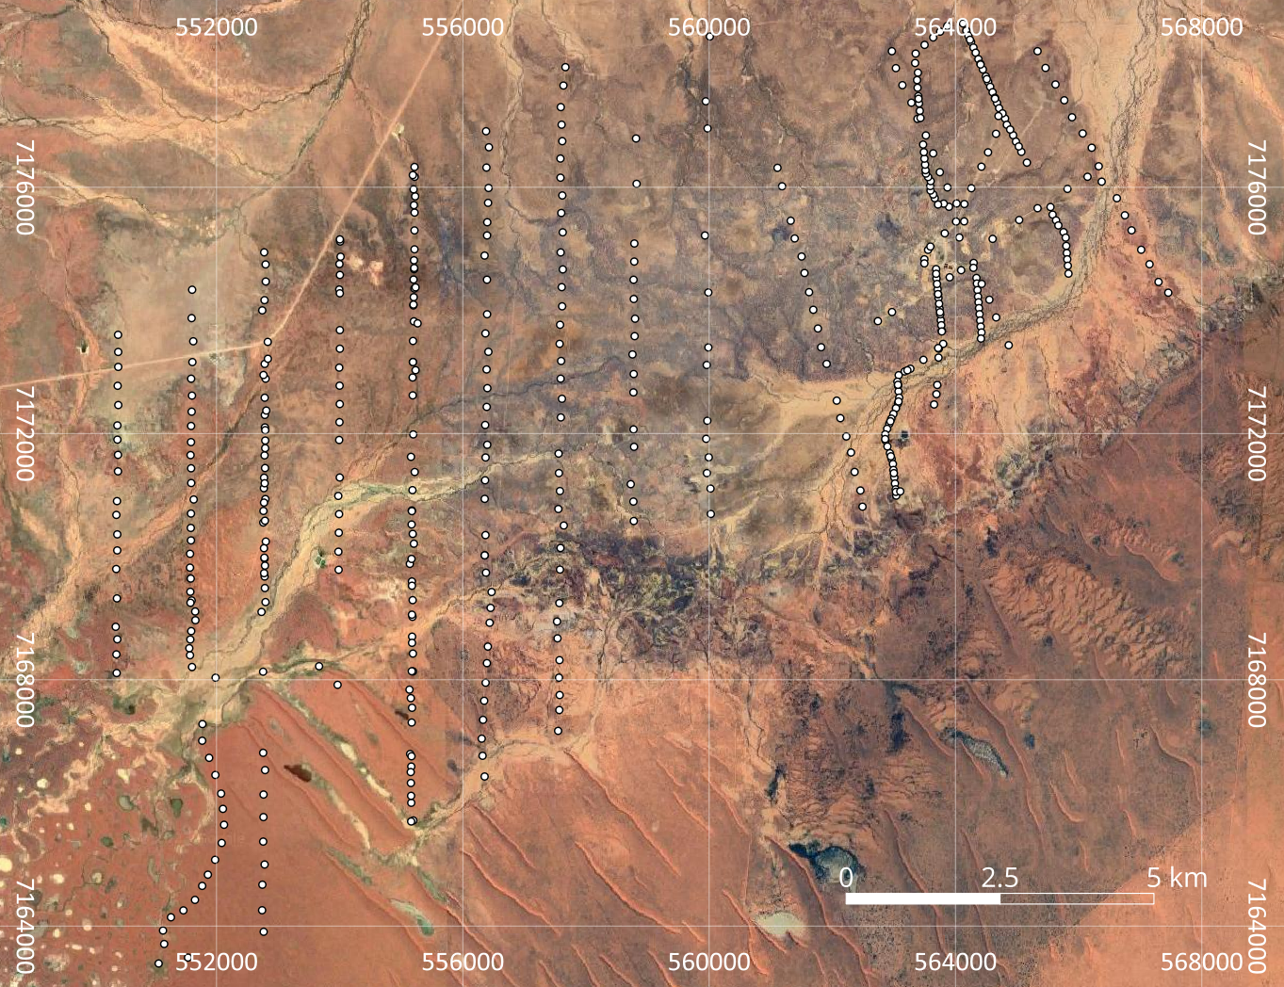

*Figure 1: Cuddapan Survey Grid Outline*

## Survey Parameters

The survey grid comprised a network of 15 lines spaced at around 1.2 km intervals. The length varied from 4 km to 11 km and station spacing typically ranged from 100 m to 300 m, determined by factors such as accessibility and terrain.

## Instrumentation

The gravity survey was performed using an absolute quantum gravimeter [1] (referred to as GravioTM thereafter) developed by Atomionics Pte. Ltd. and paired with the Trimble R4s for cm-level locational positioning. Unlike conventional gravimeters, Gravio is a quantum sensor that works based on the matter-wave interference phenomenon. This involves a free falling test mass (a cloud of atoms), which is interrogated by three laser pulses (defining the timing and displacement of the atoms), whose output is a function of the local gravity. Considering the isomorphic feature of the atoms and the absence of mechanical interaction with these atoms, the key advantage is its drift-free, absolute measurements.

The direct output *P* of Gravio is the normalized population of the atoms in a particular internal state, which is a function of the local gravitational acceleration *g* [1]:

|  | (1) |
| --- | --- |

where *keff* is the effective wave vector of the interrogation laser beams, *θ* is the azimuthal angle between Gravio (the laser beam) and the local gravity, *T* is the time interval between the three laser pulses forming a Mach-Zehnder type atomic interferometer, *α* is the chirp rate of the laser beam frequency for mapping out the Doppler shift due to the free fall of atoms, *Φvib* is the phase shift introduced by the vibration, and *C* and *A* are the contrast and offset of the sinusoid respectively. Therefore, by scanning the chirp rate across the sinusoidal fringe and acquiring the local minimum *α0*, we can derive the local gravity *g* by:

|  | (2) |
| --- | --- |

Fig. 4 shows a simplified schematic diagram of Gravio integrated into a Toyota LandCruiser Troop Carrier (A). Gravio comprises the sensor head (B, a) hosted by a tilt-stage, powered by the control module (B, b). Commands and data processing were handled by the control computer (B, c). Additionally, a differential GPS receiver (B, d) was aligned along the same vertical axis as the sensor, ensuring positional signals were collected to an accuracy of up to 2.5 cm. The 20 kWh battery unit (B, e) powered the entire system to sustain continuous operation for 48 hours.

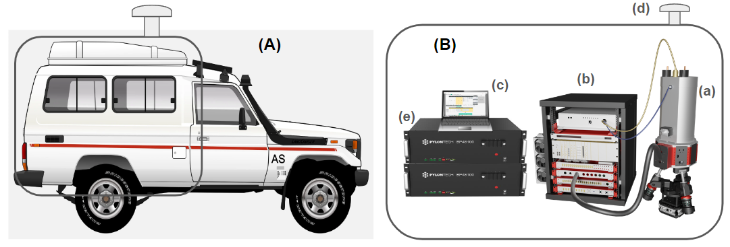

*Figure 2: Simplified Schematic Diagram of Gravio*

*(A). Toyota LandCruiser Troop Carrier; (B). Simplified Schematic Diagram of Gravio, with (a) sensor head, (b) control module consisting of the laser, power supplies, and microwave modules, (c) battery unit; (d) control computer, (e) GPS receiver*

**Table 1: Specifications of Gravio**

|  | **Specifications** | **Remarks** |
| --- | --- | --- |
| **Reading resolution** | ~0.5 mGal | Averaged resolution for g measurement |
| **Cycle time** | 3 min | Each data acquisition cycle excluding driving |
| **GPS accuracy** | x and y axes: 2.5 cm z axis: 5 cm | - |
| **Height of sensor from ground** | 1.7 m | - |
| **Height of GPS receiver from ground** | 2.2 m | - |
| **Tilt stage residual tilt angle** | <0.2° | - |
| **Operating temperature** | 25 - 40°C | Maintained using a water cooling system |
| **Power consumption** | 400 W | - |

# Data Acquisition

The quantum gravity survey was executed by the survey crew of Atomionics Pte Ltd. The crew was stationed in the Inland Oil Field facility and included 5 members including a technical supervisor. In total, the survey comprised 505 unique gravity stations, 8 of which were removed due to being outliers.

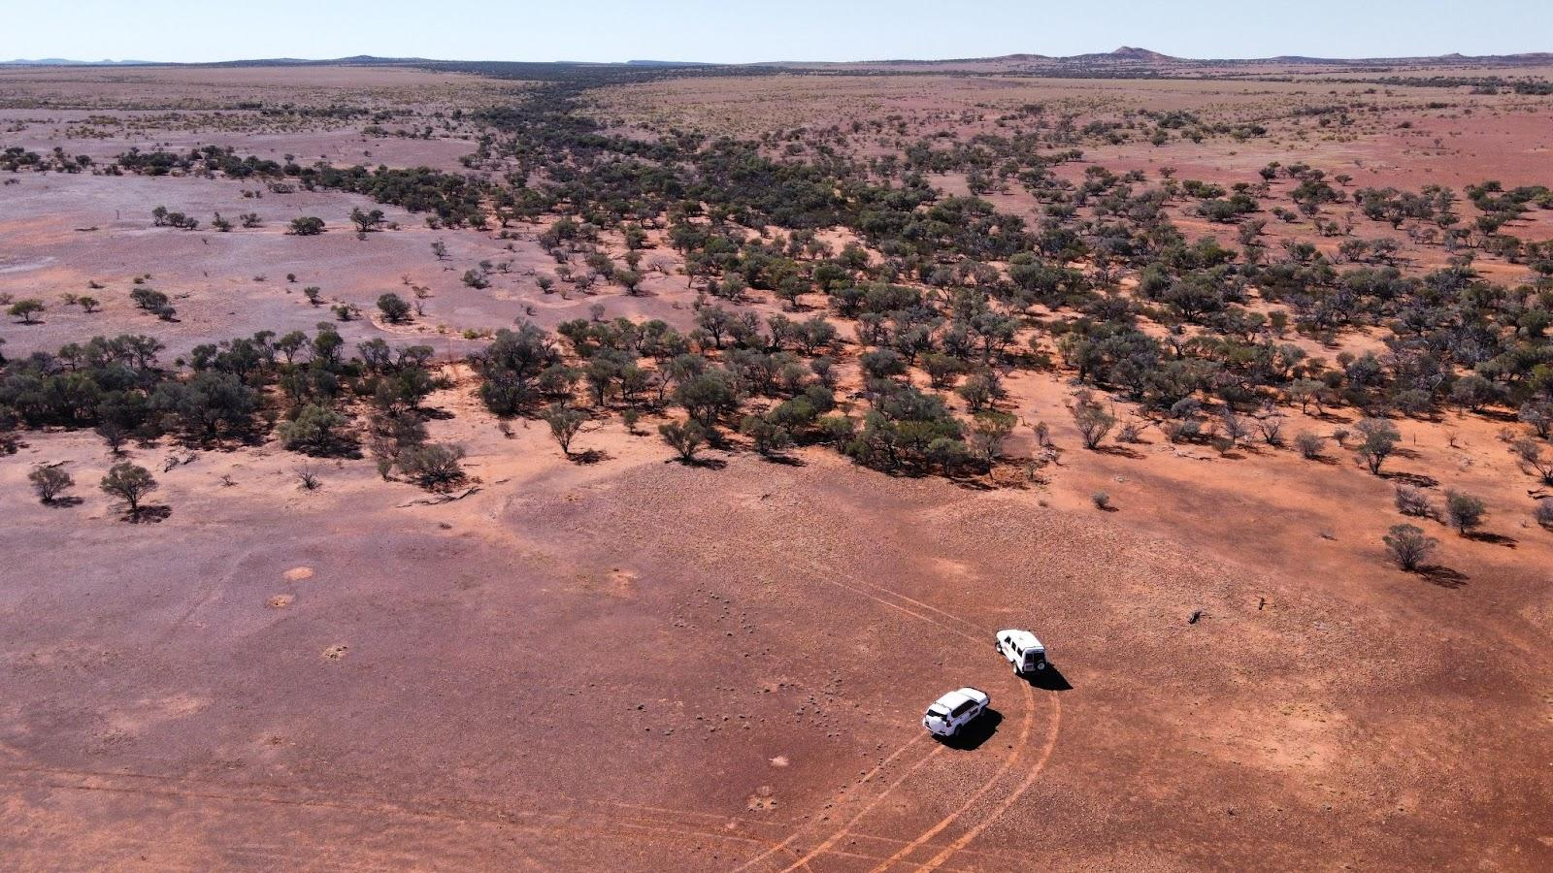

*Figure 3: Drone Footage of Survey Terrain*

## Operational Procedure

During the course of the survey, each measurement was initiated with an automated leveling process using the tilt-stage, which guaranteed the operation of Gravio within the targeted measuring range. Subsequently, in the data acquisition phase, 200 free fall experiments were carried out within a span of 2 min. This included scanning the laser chirp rate while measuring the population *P* of atoms in the desired energy state. The collected data was then processed by fitting a cosine function and retrieving *g* from Eq. (2), which took around half a minute.

## Post Corrections

Eq. (1) underscores that measurements can be influenced by environmental factors like uneven terrain and ground vibrations. Hence, incorporating tilt and vibration corrections during data processing was imperative for ensuring the reliability of the gravity survey [2]. Due to the finite precision of the tilt-stage, residual tilt persisted, necessitating further correction based on two fine tiltmeters installed onto the sensor. The misalignment between the tiltmeters and the sensor was first empirically accounted for, which permitted the true angle of Gravio (with respect to the local gravity) to be determined accurately, and therefore tilt-correct the observed *g* values.

The equivalence principle states that Earth’s gravitational acceleration cannot be distinguished from mechanical vibrations, which can induce phase noise in the sinusoid. Lab-based gravime- ters address this challenge by utilizing vibration isolation platforms but field-based sensors, like Gravio, experience vibrations from a greater variety of sources due to the dynamic nature of the environment. These vibrations must be accounted for when reading the phase of the atom interferometer for improved accuracy and precision [3]. An accelerometer was installed and it measured the vibrations *avib* experienced by Gravio for each measurement cycle. This allowed us to remove the phase contributions from vibrations, enabling the determination of the true gravity value, where:

|  | (3) |
| --- | --- |

To further minimize environmental effects, each of the survey lines underwent a smoothing process using a median filter with a filter width of 5. Following this, 8 points were identified to be outliers and excluded from the dataset. The refined dataset served as the raw gravity data for subsequent processing in the Data Processing section.

## Calibration

### Accuracy

Gravio’s accuracy was verified by comparing its gravity measurement of 978,944.77 ± 0.22 mGal against a base station with a value of 978,945.038 mGal. The coordinates of the base station were -25.54165311, 141.63104154 in the WGS84 coordinate reference system, the ellipsoidal height was 189.934 m with respect to the GRS80 ellipsoid, and the gravity datum was AAGD07. Gravio’s data was taken within 50 m of the base station intermittently throughout the duration of the survey to confirm that Gravio measures absolute gravity.

### Precision

Gravio’s performance was reviewed by acquiring gravity measurements overnight consisting of 119 repetitions as shown in Fig. 5 below. These repeats indicate the data quality of both the *g* measurement and the GPS readings. The graph shows a pk-pk fluctuation of 1.30 mGal with a standard deviation of 0.26 mGal.

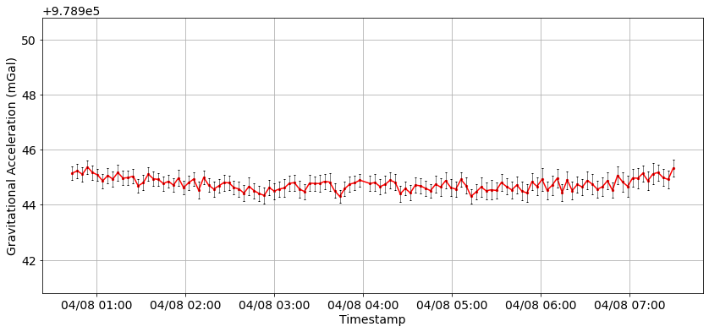

*Figure 4: Long-Term Calibration of g Measurement Consisting of 119 Overnight Repetitions*

# Data Processing

Gravio measures gravitational acceleration in a specific location at a given time. This acceleration is a composite influence of the mass distribution both above and below the sensor as well as the distance from the Earth’s surface. To extract meaningful insights, background effects that can be mathematically modeled and computed are removed and the gravity dataset is projected onto a reference plane. This process was facilitated by the application of the following corrections, which were applied using QCTool[2].

## Theoretical (Latitude)

To account for the variation in gravity with latitude, theoretical gravity *gTHEO* at the station location on the Earth's spheroid was calculated with respect to the GRS80 ellipsoid using the following formula:

| , | (4) |
| --- | --- |

where *φ* is the latitude in degrees, *ge* is the normal gravity at the equator equal to 978,032.67715, *k* is a derived constant equal to 0.001931851353, and *e* is the eccentricity where *e2* is 0.0066943800229.

## Atmospheric Effect

To adjust for the air density variations that can affect observed gravity, atmospheric effect *gATMOS* corrected for this impact using the following formula:

| , | (5) |
| --- | --- |

where *h* is the station height with respect to the reference ellipsoid in m.

## Free-Air

To remove the effects of elevation on gravity data caused by the sensor's height from a reference level, the GRS80 ellipsoid in this case, free-air correction *gFAC* was calculated using the following formula:

| , | (6) |
| --- | --- |

where *φ* is the latitude in degrees and *h* is the station height with respect to the reference ellipsoid in m.

## Tidal

The gravitational effects of the moon and the sun result in variations of up to 100s of µGal in gravity. A tidal correction *gTIDE* was applied using a tidal prediction model to remove these effects [4].

## Bullard A (Bouguer Slab)

To correct for the attraction of material between the measurement point and infinity, Bullard A *gBULLARD_A* assumes a horizontal slab of uniform density extending to infinity beneath the measurement point and was calculated using the following formula:

| , | (7) |
| --- | --- |

where *h* is the station height in m, *ρ* is density in g/cm3 equal to 2.67, and *G* is the gravitational constant in m3·kg-1·s-2.

## Bullard B (Spherical Cap)

To correct for the attraction of material between the measurement point and the horizon, Bullard B *gBULLARD_B* assumes a spherical cap of uniform density, assumed to be 2.67 g/cm3 in this case, below the measurement point [5].

## Terrain Correction

Topography can cause variations in gravity due to the distribution of mass above and below the gravity sensor. Terrain correction *gBULLARD_C* aims to remove the effects of actual topography from the data, which may differ from the topography approximated by the Bouguer slab or spherical Bouguer cap [6]. The SRTM DEM was used with an inner radius of 60 m, outer radius of 22,000 m, and reduction density of 2.67 g/cm3.

# Results and Interpretation

The geophysics team in Atomionics was in charge of conducting data processing and compilation, which were plotted with a grid size of around 170 m using Surfer[3]. All the plots in this section are in MGA Zone 54 projected CRS.

## Free-Air Anomaly

Free-air anomaly *gFA* was calculated by correcting for theoretical gravity, atmospheric effect, free-air, and tidal using the following formula:

| , | (8) |
| --- | --- |

where *gOBS* is observed gravity, *gTHEO* is theoretical gravity (re: Eq. 4), *gATMOS* is atmospheric effect (re: Eq. 5), *gTIDE* is tidal correction, and *gFAC* is free-air correction (re: Eq. 6).

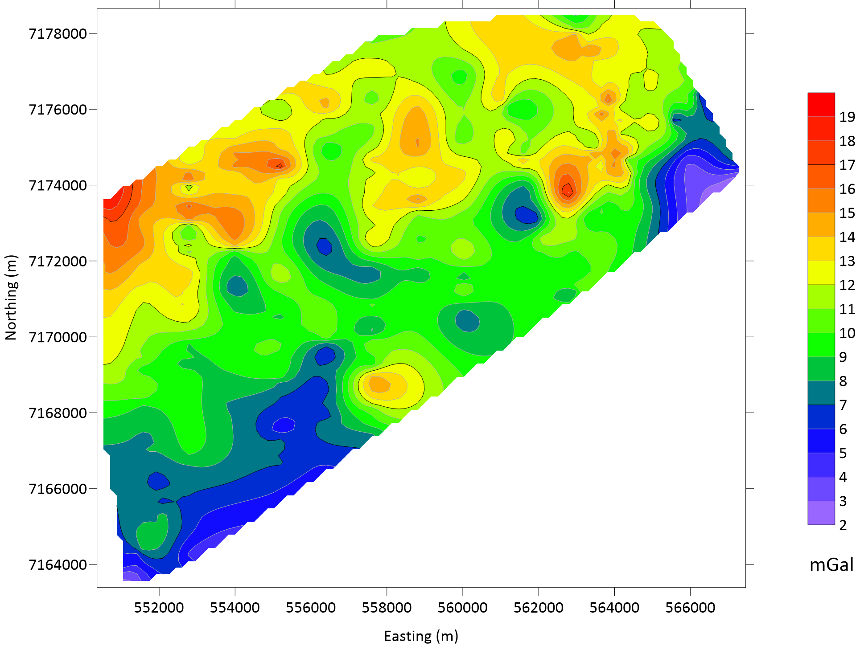

*Figure 5: Free-Air Anomaly*

1. <https://newhopegroup.com.au/bridgeport/>
2. <https://www.qctool.ca/>
3. <https://www.goldensoftware.com/products/surfer/>